Divyansh Mishra

23BCE5071

**Web Programming**

**Assignment - 8**

Q1

Code:

<!DOCTYPE html>

<html>

<head>

    <title>Basic Calculator</title>

    <script>

        function calculate() {

            let num1 = prompt("Enter the first number:");

            let num2 = prompt("Enter the second number:");

            num1 = parseFloat(num1) || 0;

            num2 = parseFloat(num2) || 0;

            let sum = num1 + num2;

            let difference = num1 - num2;

            let product = num1 * num2;

            let quotient = num2 !== 0 ? (num1 / num2).toFixed(2) : "Undefined (Cannot divide by zero)";

            let remainder = num2 !== 0 ? num1 % num2 : "Undefined";

            alert("Addition: " + sum +

                "\nSubtraction: " + difference +

                "\nMultiplication: " + product +

                "\nDivision: " + quotient +

                "\nModulus: " + remainder);

        }

    </script>

</head>

<body>

    <h2>Basic Calculator</h2>

    <button onclick="calculate()">Calculate</button>

</body>

</html>

Output:

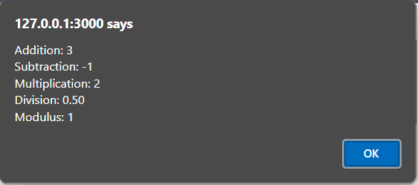

Q2

Code:

<!DOCTYPE html>

<html>

<head>

    <title>Driving Eligibility Check</title>

    <script>

        function checkEligibility() {

            let age = prompt("Enter your age:");

            age = parseInt(age) || 0;

            if (age >= 18) {

                alert("You are eligible to drive!");

            } else {

                alert("Sorry, you are not eligible to drive. You must be 18 or older.");

            }

        }

    </script>

</head>

<body>

    <h2>Driving Eligibility Checker</h2>

    <button onclick="checkEligibility()">Check Eligibility</button>

</body>

</html>

Output:

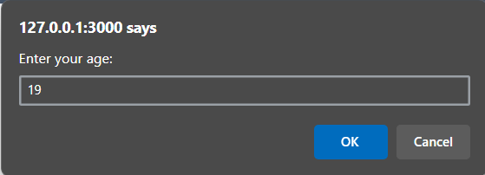

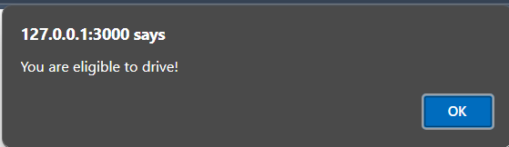

Q3

CODE:

<!DOCTYPE html>

<html>

<head>

    <title>Student Confirmation</title>

    <script>

        function getRegistrationNumber() {

            let isStudent = confirm("Are you a student?");

            if (isStudent) {

                let regNo = prompt("Enter your Registration Number:");

                if (regNo) {

                    alert("Your Registration Number: " + regNo);

                } else {

                    alert("Registration number cannot be empty.");

                }

            } else {

                alert("You must be a student to proceed.");

            }

        }

    </script>

</head>

<body>

    <h2>Student Registration</h2>

    <button onclick="getRegistrationNumber()">Enter Registration Number</button>

</body>

</html>

OUTPUT:

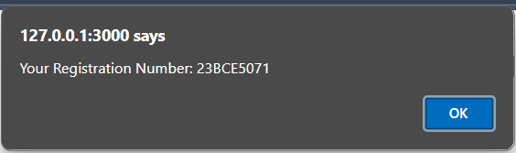

Q4

CODE:

<!DOCTYPE html>

<html>

<head>

    <title>Labour Cost Calculator</title>

    <script>

        function calculateCharges() {

            const ratePerHour = 45;

            let hoursWorked = prompt("Enter the number of hours worked:");

            let costOfMaterials = prompt("Enter the cost of materials:");

            hoursWorked = parseFloat(hoursWorked) || 0;

            costOfMaterials = parseFloat(costOfMaterials) || 0;

            let labourCost = ratePerHour * hoursWorked;

            let totalCharge = labourCost + costOfMaterials;

            alert("Labour Cost: Rs. " + labourCost + "\nTotal Charge: Rs. " + totalCharge);

        }

    </script>

</head>

<body>

    <h2>Labour Cost & Total Charge Calculator</h2>

    <button onclick="calculateCharges()">Calculate</button>

</body>

</html>

OUTPUT:

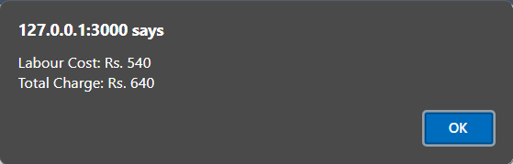

Q5

CODE:

<!DOCTYPE html>

<html>

<head>

    <title>Q4</title>

</head>

<body>

<script>

    var regNo = prompt("Enter your registration number:");

    var name = prompt("Enter your name:");

    document.write('<div style="border: 3px solid red; padding: 10px; width: 150px; text-align: center; font-weight: bold; font-size: 20px; margin-bottom: 20px;">' + regNo + '</div>');

</script>

<div id="nameDisplay" style="border: 2px solid black; padding: 10px; width: 150px; text-align: center; font-weight: bold; font-size: 20px; color: red;"></div>

<script>

    document.getElementById("nameDisplay").innerHTML = "<i>*" + name + "*</i>";

</script>

</body>

</html>

OUTPUT:

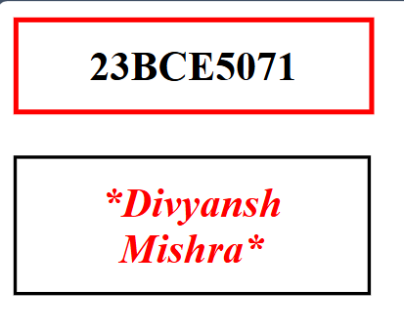

Q6

CODE:

<!DOCTYPE html>

<html>

<head>

    <title>Ticket Booth</title>

    <script src="script.js" defer></script>

</head>

<body>

    <h2>TICKET BOOTH</h2>

    <label>Adults (₹10 each)</label> <br>

    <input type="number" id="adultTickets" min="0"><br><br>

    <label>Children (₹5 each)</label> <br>

    <input type="number" id="childTickets" min="0"><br><br>

    <button onclick="calculateTotal()">Total</button>

    <input type="text" id="totalAmount" readonly>

</body>

</html>

OUTPUT:

